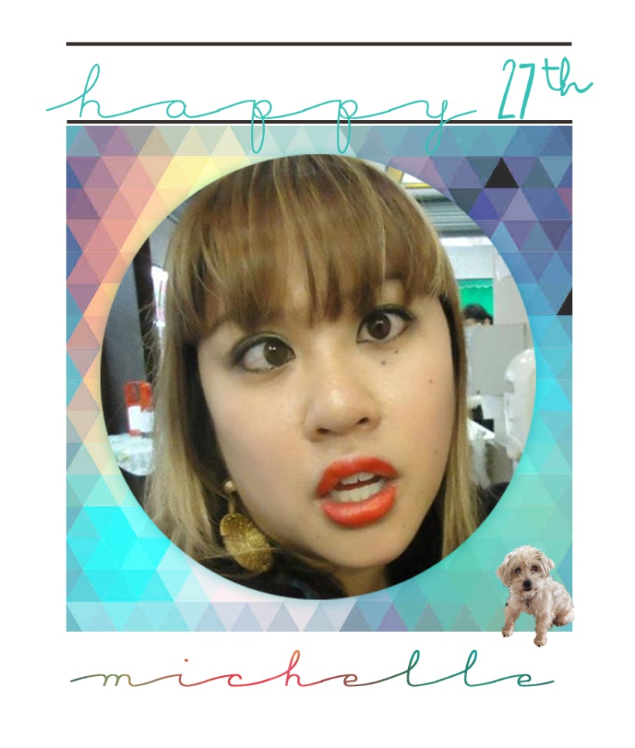

Happy birthday message. Known for crazy adventures. Where will you end up this time?

Let’s go!

START

[insert story: sneak in somewhere]

Choose between:

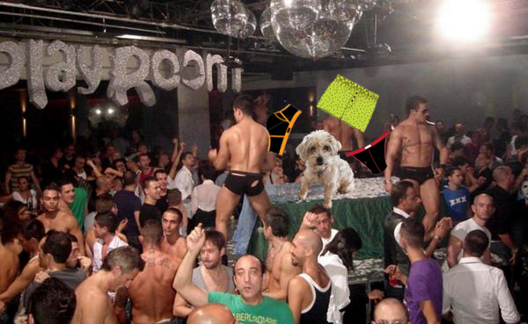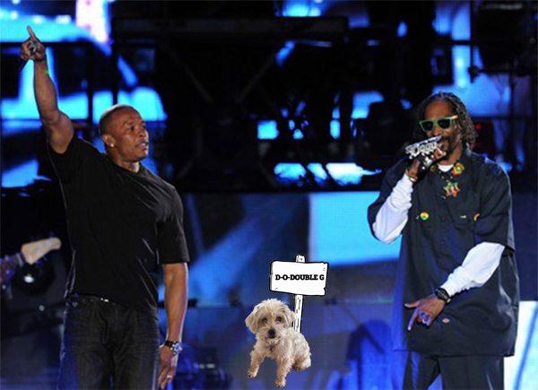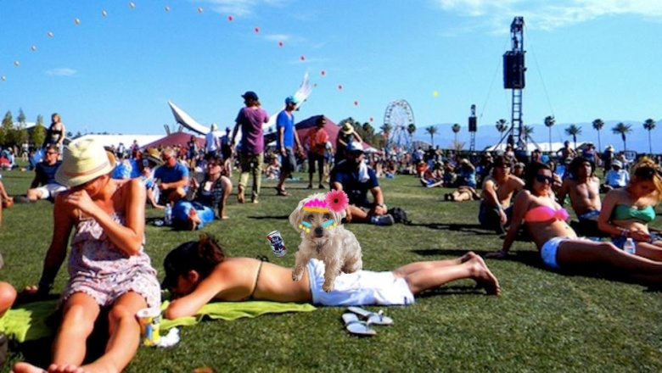

# Option 1: Gay Club

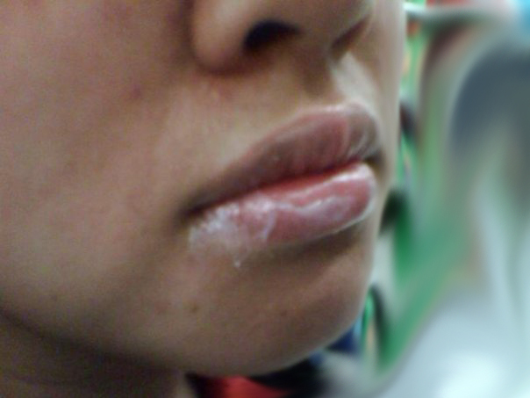

You are dancing and then you feel something underneath your foot. You bend over and pick it up. It’s your lucky day: it’s MAC lip balm, yes the expensive kind. Perfect timing too because your lips are feeling dry, why don’t we put that sucker on, double layers. As the night goes on and the clock strikes midnight you find yourself sleepy. Where did Jessie and Kevin go? Well, might as well sit down here on the dance floor. Well, might as well close your eyes for a little bit while you wait for them. The next thing you know, a security guard is waking you up and kicking you out of the club for falling asleep on the dance floor. Now you are stuck outside with a dead phone with no friends in site. Well, might as well go get something to eat. What are you in the mood for? 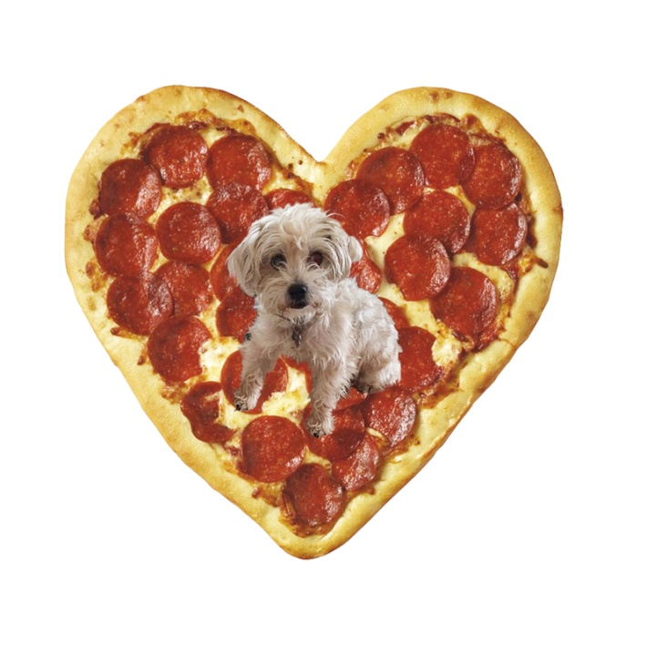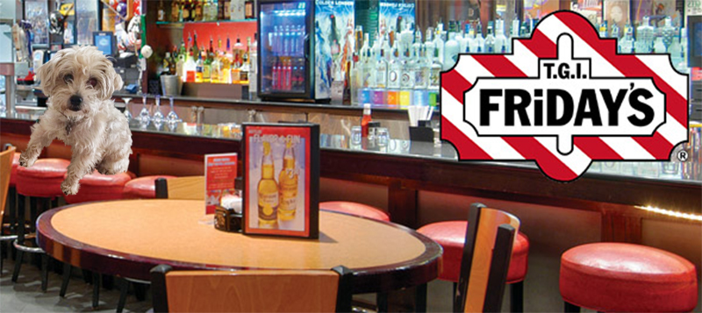

# FINAL: Gay club + Pizza = NYC

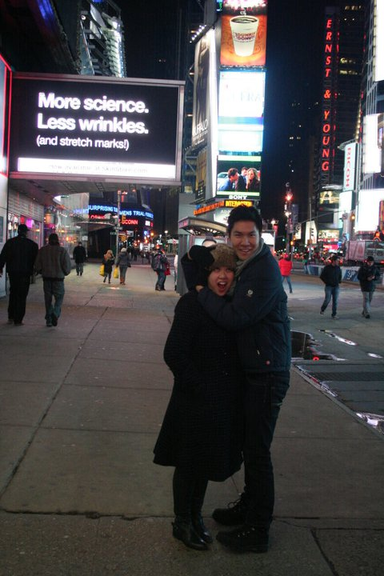

Gay clubs and pizza? NYC is the perfect place for you! One of our fondest moments of you is visiting you in NYC.

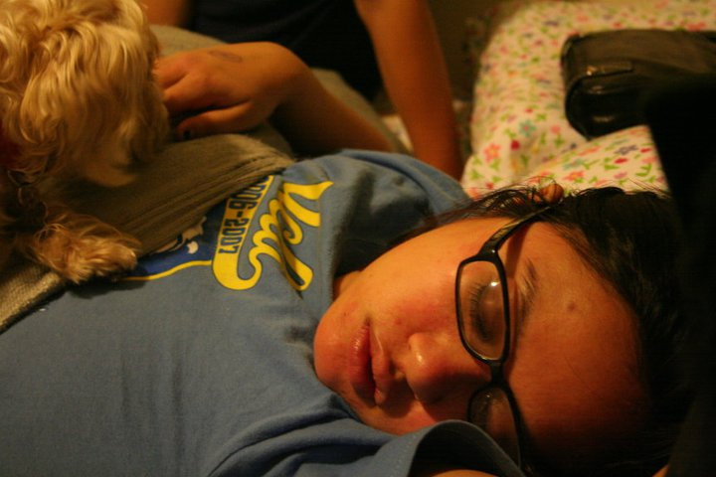

# FINAL: Gay Club + TGIF = AMC 12 in La Jolla

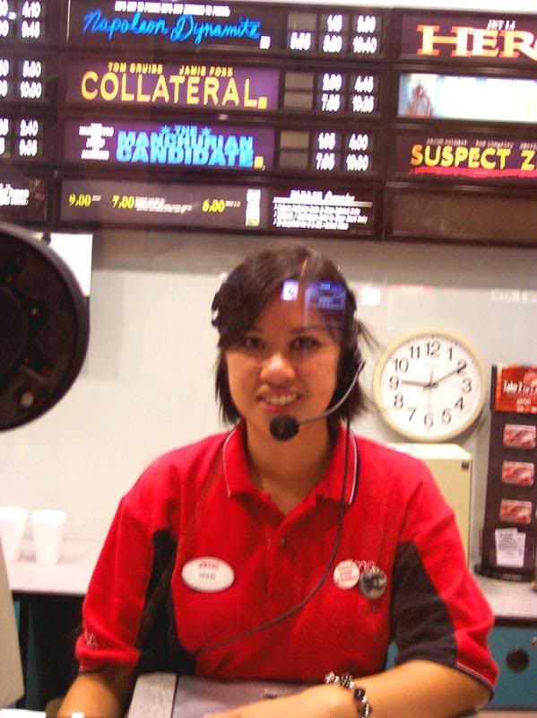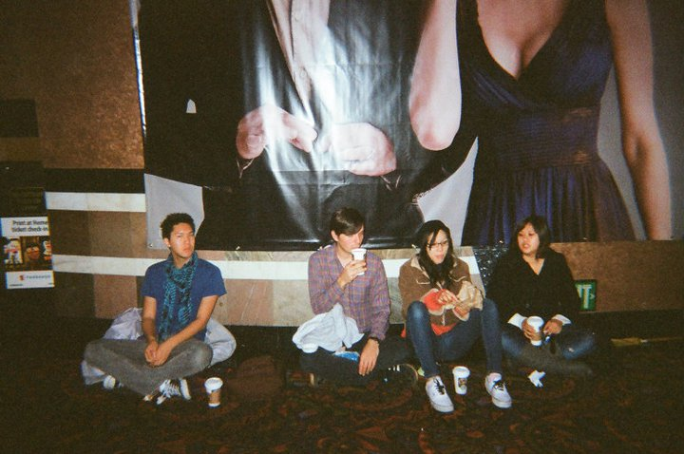

Hiromi – amc, high school, got close, amc drama, ton of free tickets



# Option#2: Coachella:

You gotta write an article and work the booth. Doing what you do best, you write your piece in the car while simanteously insulting everyone on the drive up. As you work in the tent, you become so thirsty. There only option is vodka and red bull. Lauren becomes white lightening while dancing with two muscle boys. Hipsters, what is this special brownie people speak of? Freegan brownies

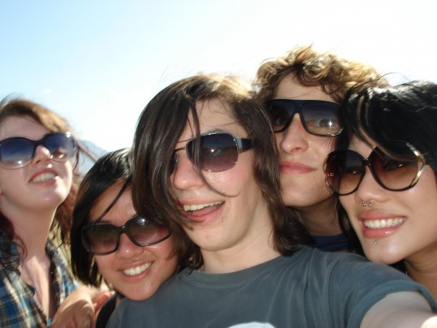

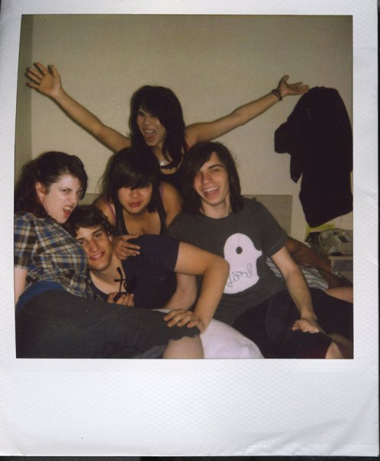

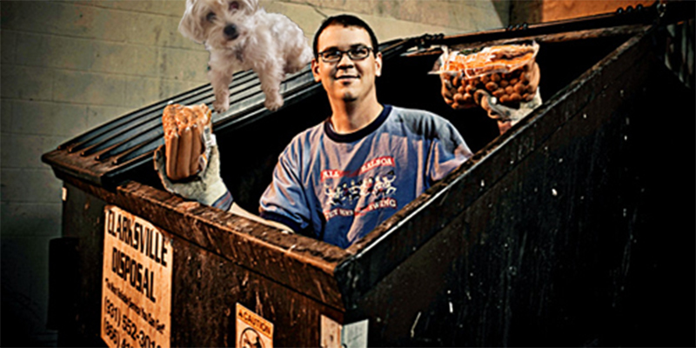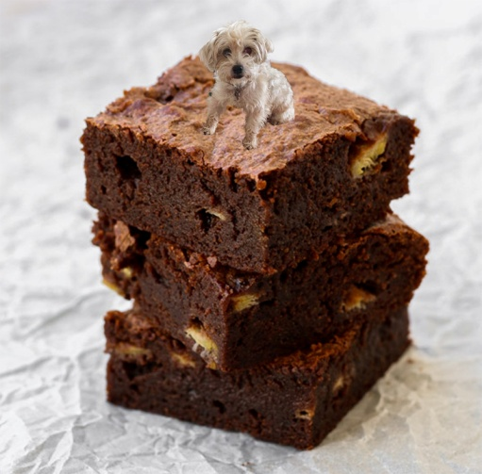

# FINAL: Coachella + Freegan = SF

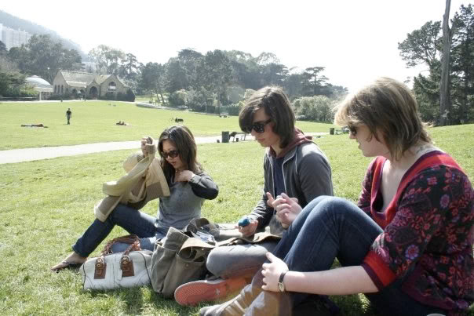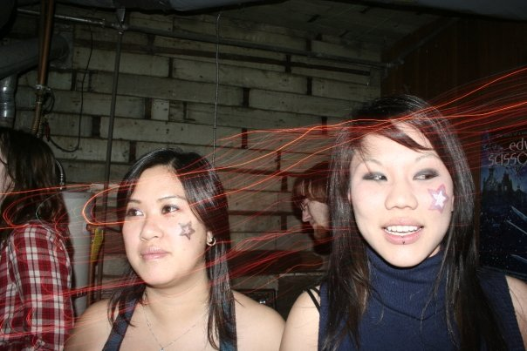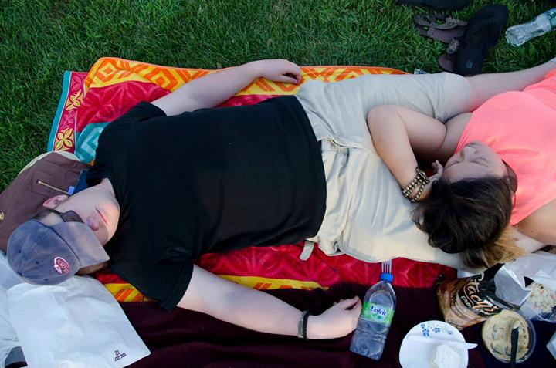

# FINAL: Coachella + Special Brownies = Amsterdam

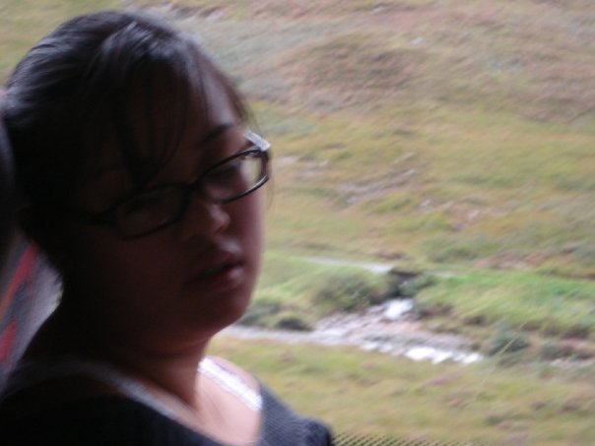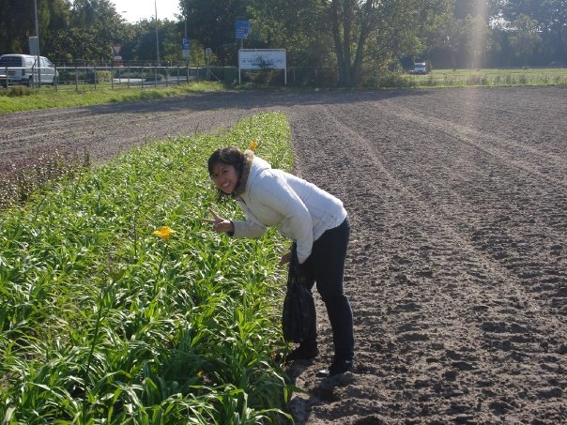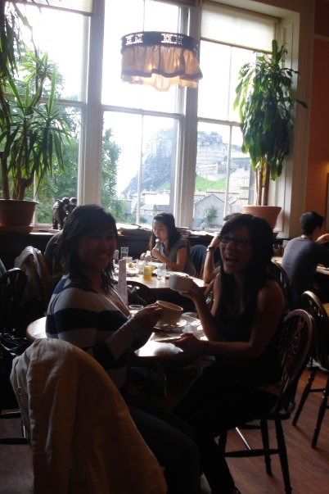

Option #3: Snoop Dog

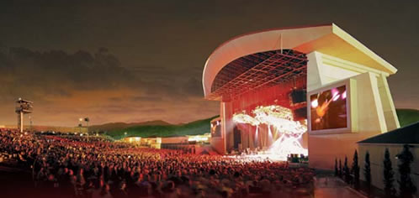

­$6 tickets, nosebleed seats, borrow light. For some reason, you are hungry. Where to?

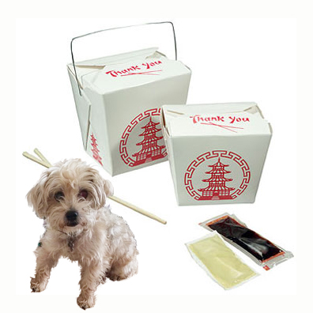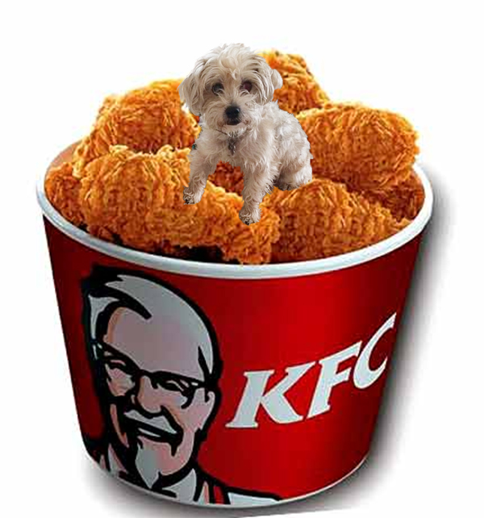

FINAL: snoop + kfc = Brazil

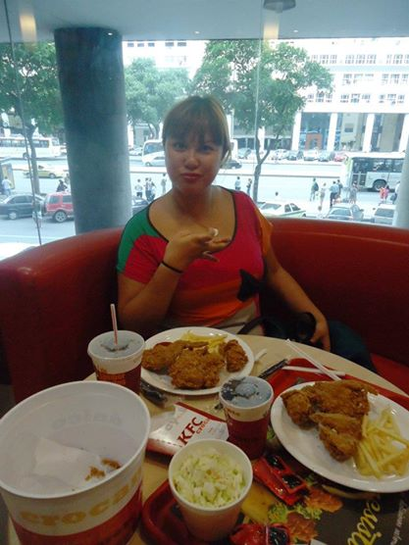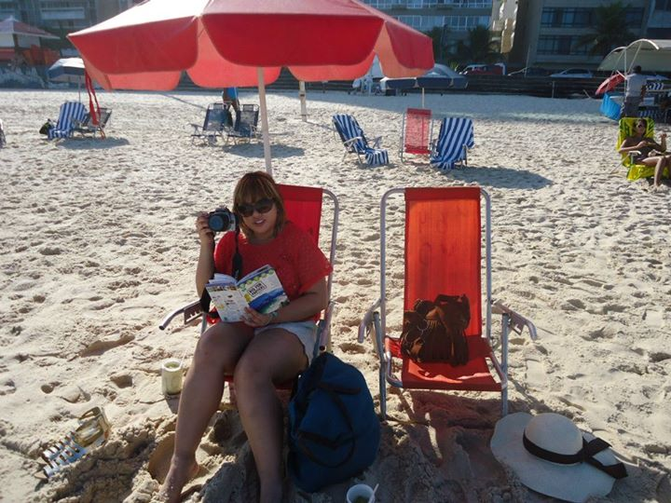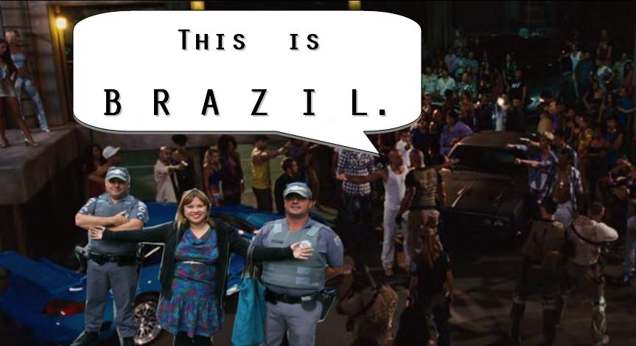 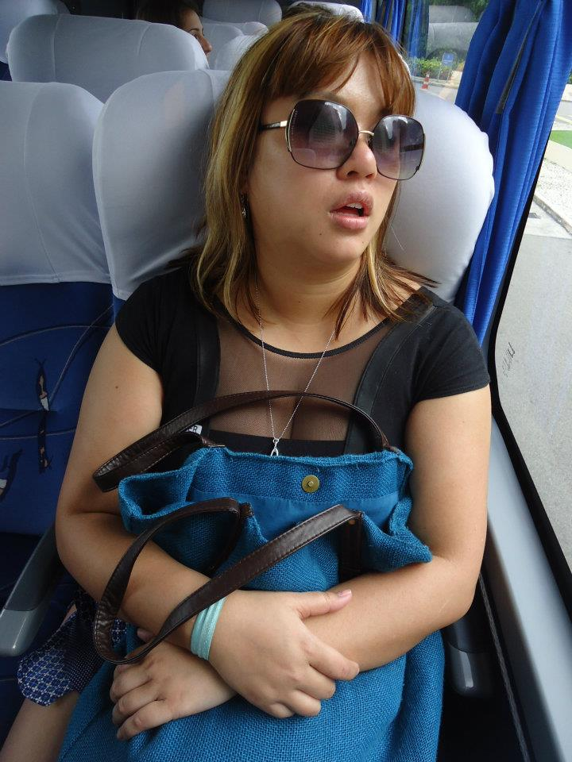

FINAL = SNOOP + CHINESE FOOD = la

